«DisplayName»
Using Blender 2.7 for Animation - Part 2 - Text & Indirect Lighting
Creating 3D text
- File, Save As, choose your home drive on left (such as H:), then in the second box name it 3da2glow
- In Object Mode in the "Create" tab, click "Text"
- Adjust the camera to see all of the text:
  - Place the mouse pointer over the 3D view then push 0 on NUMPAD for camera view (top left of 3D view should now say )
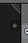
  - If you do not see the Properties panel on the right, there will be a small gray plus sign near the top right of the 3D View, and you would have to click that to show properties.
  - In the Properties panel, make sure “Lock Camera to View” is checked.
  - To animate the camera, you’ll still have to right-click the outline of the camera before you can Insert a LocRot keyframe as usual:

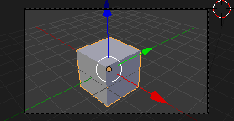 | 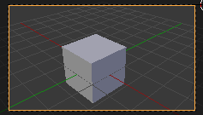 | 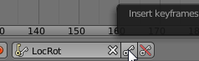

- In Edit Mode, you can backspace over the sample text and start typing
- Go back to Object Mode
- Click the Object data button
-Here you can increase the "Extrude" and the Bevel "Depth" to make the text 3D
- In Object Mode, select the Text, (add a new material if you don’t have Emit option) then change Emit to around 1.0
- Whatever color you make the object will become the color of light it emits
Create a background for the object (in object mode you could use "Add", "Mesh", "Plane") so that the emit can glow onto something.
- Place the background object very close to the text
- (If you select the plane and don’t see the color swatch , add a new material and) make it gray (50% or so)—it must be darker than the default color to be dark enough to let the glow show.
In the World Button tab, enable indirect lighting:
- Click "World" button
- Click "Approximate" (even if button is gray) & make sure "Indirect Lighting" is checked.

Hint
To make the glow effect more visible:
- Delete all lights in the scene
- Set the background color to black (Click World button , then click the color under "Horizon Color" then set the gray scale all the way down or set the values to 0)

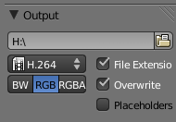
To Render Animation, always first change end frame by dragging “End” at bottom, then click the Render button, browse to your H: drive (or C:\Users\Owner\Documents [or Documents folder of your user if not Owner]), and choose H.264 for HD compression so it saves as a video file instead of images:
Then at the top of the Render button tab, click “Animation” button

Part 2 Overview
Text and Indirect Lighting
(each bold phrase is worth 1 point out of 10)
- There must be at least one text object (extruded and beveled)
- There must be at least one object with indirect lighting (Emit property) such as a text object, and the light must be cast on something (such as plane) and visible when you render the animation
- At least one of the objects must be animated
- You must save the animation as an h.264 video file to your home drive

